Program 3

Working with Remote, Live, Distributed

Earthquake Data using C++
CSC 1300, Spring 2026

Image was AI generated with ChatGPT in June 2025.

Required Skills & Knowledge

- For Loops
- Arrays
- Functions
- Makefiles
- JSON & cURL
- Distributed Data

Assignment Objective
- You will be able to develop and implement an algorithmic solution for interacting with a remote service.
- You will practice working with data in JSON format.
- You will be able to compile and run programs using a Makefile.
THIS IS NOT A TYPICAL PROGRAMMING ASSIGNMENT! The purpose of this assignment isn’t just to practice writing code with functions, loops, and strings in C The primary purpose of this assignment is to introduce you to the concept of accessing distributed, remote data from your programs and to practice by finishing a basic program that accesses real, live data. We want you to see the potential for societal impact of distributed data systems in solving social problems such as natural disaster monitoring.

What You Can’t Use In This Program
If you do any of the following, you will receive a 0 on some or all of the assignment and possibly get charged with an academic integrity violation (this is very serious).
- You may not use code or syntax in your assignment that has not been taught in CSC 1300 class without referencing your source. How do you reference your source? By providing a link/URL in a multi-line comment in the section of code where you use “non-1300” code. Otherwise, this will be considered plagiarism. It is safer to use course materials (slides & example programs) to help you create solutions to the assignments.
- Do not use the following programming constructs for Program 3. If you use these, you will get a zero on the assignment. We need to make sure you can do the basics first before adding these types of constructs.
- Do not use pointers, structures, or classes
- Do not use any STL classes other than vector.
- You may not (ever) use the following in your programming & lab assignments in CSC 1300:
- while(true) or while(1)
- goto statements
- recursion
- exit()
- ternary operators or any syntax requiring a ‘?’
- lambda functions
- try-catch

- You may not use generative AI (genAI) in any way for this assignment.
This is not a group effort. Programming assignments are like exams in this class and should be your own work. You may discuss the assignment with other students in the class but you are not allowed to share/send your code to any other person (friend, past/present students, parent, etc.) or view/receive code from anyone (unless they are a TA or instructor for this class). This is considered cheating in this class and you will get a zero on the assignment (even if you are the one who wrote the code and sent it to someone else). Get help from TAs, tutors & instructors when you get stuck!

Assignment Description
Your first job in this assignment is to complete a C++ program that will:
- read data from a real, live, remote United States Geological Survey (USGS) earthquake data repository,
- filter the given data, and
- display the data to the screen in the specified way.
Then, you will answer questions about the program and submit the answers along with your solution.

Remote, Distributed, LIVE Data
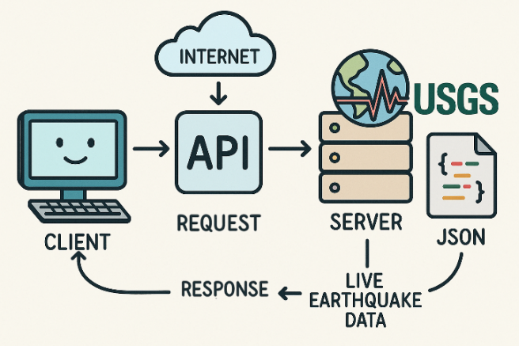
When you need data from a remote source (the server), you use that source’s Application Programming Interface (API) to request the data.
Your computer (the client) uses the API over the network (internet), the server accesses the data and sends it back in a way you can use.
  - The API acts as a messenger between you and the system that stores the data.
  - In many cases, the data isn’t stored in just one place—it might be spread across multiple locations like different servers or databases.
  - However, you don’t need to worry about that because the API handles that part.

In this assignment, you will be retrieving data from a remote source (USGS Earthquake data) https://earthquake.usgs.gov/earthquakes/feed/v1.0/summary/all_month.geojson and the data will be returned in JSON format. This data is LIVE, which means it is constantly updated in real time!

JSON Format
JSON text format is very readable by both humans and computers. Below is an image of a JSON object.

JSON objects contain key:value pairs.
For example, the key “place” has value “Volcano Islands, Japan region”.
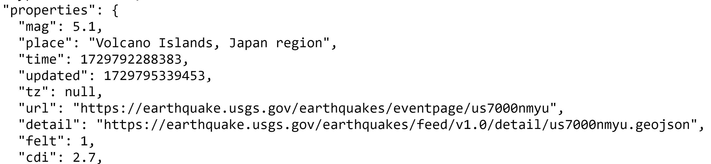

Detailed INSTRUCTIONS

REQUIRED SET-UP
- Use your Program 3 folder for this assignment.
- Download the following files from ilearn:
  - Spring 2026 Program 3 Given Files.zip
  - Makefile Lecture Slides and Example
- Extract the given files in your Program 3 folder. Your Program 3 folder should contain the following files:
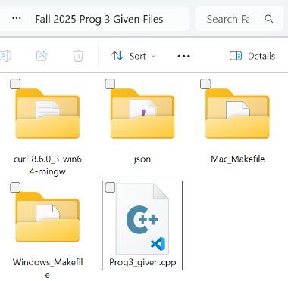
  - curl-8.6.0_3-win65-mingw
  - json
  - Mac_Makefile
  - Windows_Makefile
  - Prog3_given.cpp
- Next, rename Prog3_given.cpp to Prog3.cpp.
- Next, copy the correct Makefile to your Program 3 directory.
  - if you have a Mac, you need to copy the Makefile from the Mac_Makefile folder and place directly under your Program 3 folder.
  - If you have a Windows laptop, copy the Makefile from the Windows_Makefile folder and place directly under your Program 3 folder.
- Copy the file named libcurl-x64.dll that is inside the curl-8.6.0_3-win64-mingw folder and paste it directly inside the Program 3 folder.

See the screen capture below that shows what the Program 3 folder will look like after you have done all these steps.
If you do not have the same folders in your Program 3 directory, you have missed a step!
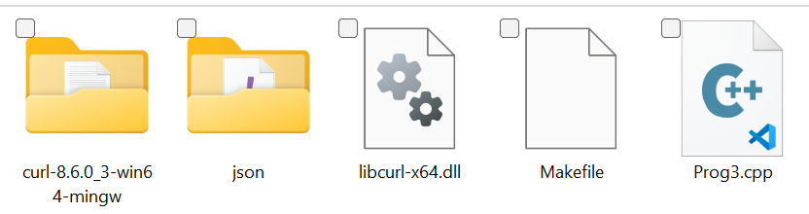

FINISH THE PROGRAM CODE

- Look at the JSON file that you will be accessing with your code. This will help you understand the code already written for you and aid in adding to the program The URL is https://earthquake.usgs.gov/earthquakes/feed/v1.0/summary/all_month.geojson.
- Add these new #includes
  - #include <curl/curl.h>
This open source library is required to use cURL. CURL is used to transfer data specified with URL syntax, which you will need in this program since you are accessing and transferring data from an HTML page.
More information: https://curl.se/
  - #include <nlohmann/json.hpp>
The data you will be accessing is in JSON format, which is why you need this library to be able to access and read the data with your program. The JSON for Modern C++ library was created by Mr. Lohmann and is available at https://github.com/nlohmann. This library is provided for you in the given files.
  - #include <sstream>
In this program, you are going to use the ostringstream class from the sstream library to temporarily store data that you download from a website. Just like you used ofstream to write to a file, you’re using ostringstream to write to a string variable in memory.
More information: https://cplusplus.com/reference/sstream/ostringstream/
  - In the main function of your source code there is a function call to downloadDataFromURL() where the argument is a string URL. You need to change the string to the URL “https://earthquake.usgs.gov/earthquakes/feed/v1.0/summary/all_month.geojson” (make sure the string contains the double quotes). This is the URL of the website you are accessing.
- You should not modify any of the code in the downloadDataFromURL()function, but you may want to read through the function (and comment block at top of function) to see what it does.
- The main function in this program contains C++ exception handling with keywords try and catch. You don’t have to modify this part of the code at all. For more information on try & catch (if you are curious), visit https://www.w3schools.com/cpp/cpp_exceptions.asp
- A for loop to iterate through each element in the features array is already given to you which will print the first 10 earthquakes that have a magnitude of 4.5 or higher once you complete the if statement.
Remember that JSON objects contain key-value pairs. So, in the “properties” dictionary, there is a “mag” key and you want your if statement to check if the “mag” key is greater than or equal to 4.5. So, the if statement should look like this:
if (element[“properties”][“mag”] >= 4.5)
- Now, you need to add one more for loop that will print all of the earthquakes (not just the first 10) that
caused a tsunami.

COMPILING & RUNNING WITH THE MAKEFILE
Compiling this program will be different then any other program we have done in this class. It requires including complete file paths to some of the files we had you download. Do not try to type out the compile line for this program. You will have to use the given Makefile but it will only work if you modify the Makefile as described below.
- Update the file paths in your Makefile according to the directions for your operating system below.
- Use the Makefile presentation slides and example provided to see how to compile in your command prompt/terminal with the make command and then to run the program with the make run command.
  - make: builds the executable file (equivalent to running your g++ statement)
  - make run: runs your executable file
  - make clean: removes the executable file from your directory

Windows
            - Make sure you are using the provided Windows version Makefile.
            - Open it with VS Code.
            - Copy the file path of your Program 3 solution files.
              - To find your include path, navigate to your Program 3 directory in your File Explorer.
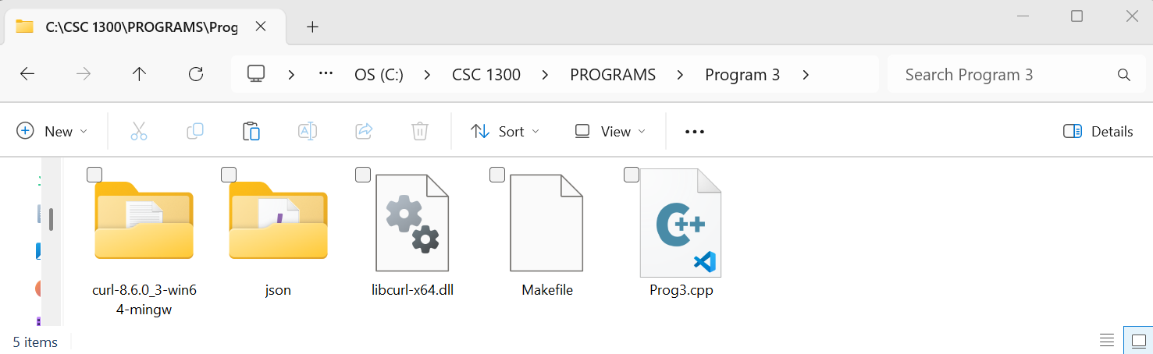
CLICK HERE
              - Then, highlight the bar at the top to find your include path
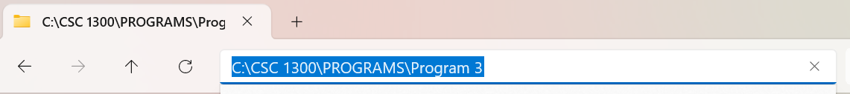

            - Change YOUR/PATH/HERE in THREE places in the Makefile.
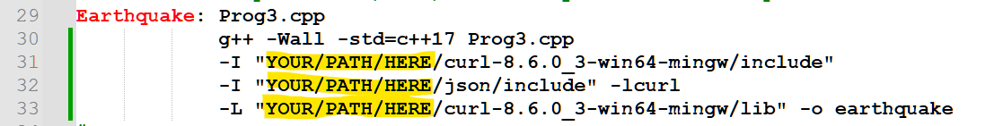
On my computer, I changed the file path to this:
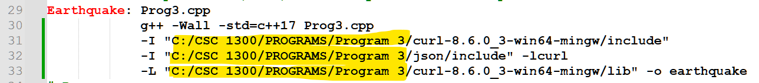
(your programming assignment folder may be in a different location on your computer)

Mac
            - Make sure you are using the provided Mac version Makefile.
            - Open it with VS Code.
            - Copy the file path of your Program 3 solution files.
              - To find your file path, navigate to your Program 3 directory in the terminal.
              - Then, type in the pwd command, which will return your path (remember, ls to display what is in your current directory and cd to navigate through the directories).
            - Change YOUR/PATH/HERE in TWO places in the Makefile.
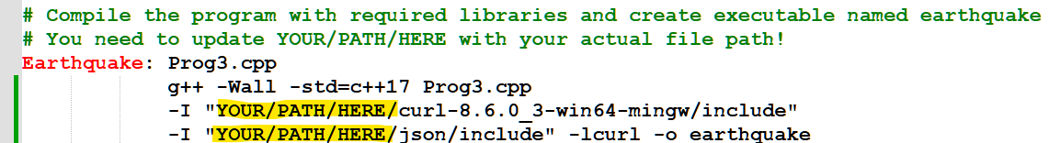

Sample Output
- There is no user input in this program.
- If you successfully retrieved the data and printed it on the screen, it should look similar to the sample below this when you run it.
- Your data/output WILL be different since the data is dynamic (live updated).
I ran this program at 8:36am CDT on 3-5-2026.

Earthquakes with magnitude greater than or equal to 4.5:
Earthquake 1:
Place: "259 km WSW of Adak, Alaska"
Magnitude: 4.5

Earthquake 2:
Place: "10 km W of Edgefield, Louisiana"
Magnitude: 4.9

Earthquake 3:
Place: "central East Pacific Rise"
Magnitude: 5

Earthquake 4:
Place: "53 km NW of Hirara, Japan"
Magnitude: 5.2

Earthquake 5:
Place: "109 km SSE of Burica, Panama"
Magnitude: 5.2

Earthquake 6:
Place: "199 km N of Likis├í, Timor Leste"
Magnitude: 4.6

Earthquake 7:
Place: "south of the Fiji Islands"
Magnitude: 4.8

Earthquake 8:
Place: "43 km NW of Coquimbo, Chile"
Magnitude: 4.8

Earthquake 9:
Place: "76 km SSE of Shihezi, China"
Magnitude: 5

Earthquake 10:
Place: "270 km ESE of Attu Station, Alaska"
Magnitude: 4.5

Earthquakes that caused a tsunami:
Earthquake 1:
Place: "224 km ESE of Attu Station, Alaska"
Magnitude: 6.4

Earthquake 2:
Place: "222 km ESE of Attu Station, Alaska"
Magnitude: 5.4

Earthquake 3:
Place: "235 km ESE of Attu Station, Alaska"
Magnitude: 5.2

Earthquake 4:
Place: "229 km ESE of Attu Station, Alaska"
Magnitude: 5.3

Earthquake 5:
Place: "92 km SW of Nikolski, Alaska"
Magnitude: 5.5

Earthquake 6:
Place: "93 km SW of Nikolski, Alaska"
Magnitude: 6.1

Earthquake 7:
Place: "55 km NNW of Kota Belud, Malaysia"
Magnitude: 7.1

Earthquake 8:
Place: "155 km N of Arecibo, Puerto Rico"
Magnitude: 5.1

Earthquake 9:
Place: "7 km NNW of Meadow Lakes, Alaska"
Magnitude: 3.8

Earthquake 10:
Place: "48 km W of Port-Olry, Vanuatu"
Magnitude: 6.4

Earthquake 11:
Place: "6 km NW of Delta, B.C., MX"
Magnitude: 4.18

Earthquake 12:
Place: "8 km NNW of Meadow Lakes, Alaska"
Magnitude: 4.6

Earthquake 13:
Place: "46 km NNW of Beluga, Alaska"
Magnitude: 4.4

AnsWER THESE QUESTIONS
Create a Word document named Prog3_documentation.docx in your Program 3 folder and answer the following questions:

Question 1
Take a screenshot of your output when you run your program and paste it in your Prog3_documentation.docx document.

Question 2
In this assignment you retrieved data from a remote source (USGS Earthquake data) at earthquake.usgs.gov/earthquakes/feed/v1.0/summary/all_month.geojson. This data is LIVE, which means it is constantly updated in real time, and it contains all detected earthquakes in the past month.
At the time of updating this part of the document on March 5, 2026, below is a screenshot of the data.
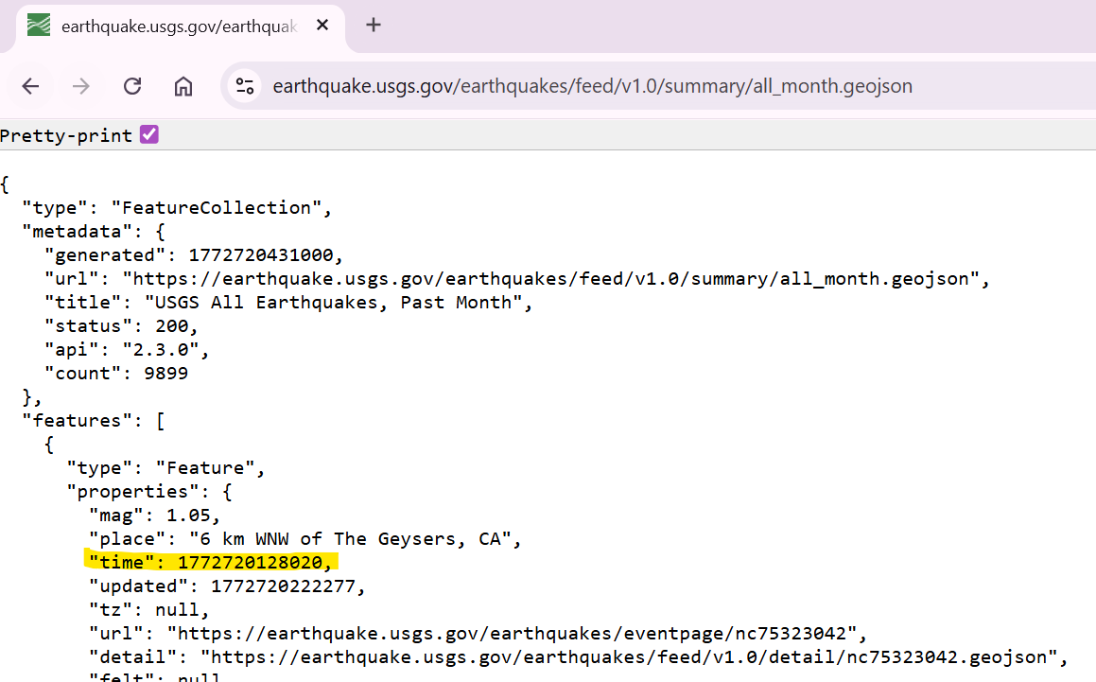
There were 9,899 earthquakes in the last month. Notice the first earthquake in the file had a timestamp (highlighted in yellow) of 1772720128020. This is a Unix timestamp in milliseconds since the Unix epoch (January 1, 1970, at 00:00:00 UTC). In other words, when this earthquake happened, it had been 1,772,720,128.020 seconds since January 1, 1970, and if you convert this to a human-readable date, it is Thursday, March 5, 2026 at 8:15:28.020 AM US Central time zone.
- Go to this URL right now and take a screenshot of the first earthquake in the file similar to my screenshot below.
- Paste the screenshot in your Prog3_documentation.docx file.
- Go to https://www.epochconverter.com/ and type in the Unix timestamp in milliseconds to convert it to a human-readable date in your time zone.
- Write the human-readable date in your Prog3_documentation.docx file.

Question 3
In simple terms and in your own words, define the following terms. Do not give us a a generative AI answer.
- Remote Data
- Distributed Data
- API
- JSON

QUESTION 4
Describe a different real-world situation where a large amount of data must be retrieved from one or more remote servers to provide some type of public service. There are many correct answers for this question.

Program Report
Fill out this program report and take a screenshot of the confirmation page after submitting and name it Prog3ReportProof.
Program Report Link: https://tntech.co1.qualtrics.com/jfe/form/SV_5vhCYdoB1bhJXM2

Grading
Make sure to test your program with the sample output and look at the rubric attached to the programming assignment so you know exactly how you will be graded.

what to turn in
Create a zip file yourTTUUsername_prog3 containing the following files and upload it to ilearn. Replace yourTTUUsername with your TTU username. Example: acrockett43_prog3.zip
- Prog3.cpp
- Prog3_documentation.docx
- Prog3ReportProof

